
BOSTON
INTERNATIONAL COLLEGE
END TERM EXAM
Level: Bachelor |  | Year : 2025
Program: BCSIT Sem: II |  | Full Marks : 100
Course: Data Structure and Algorithm |  | Time : 3 hrs

Candidates are required to give their answers in their own words as far as practicable. The figures in the margin indicate full marks.

Group A
Very Short Answer Questions
Attempt all the questions. Give your answer in few lines: 10*2=20
- What is Data Structure?
- Define time complexity?
- What is tail and direct recursion?
- What is a collision in a hash table?
- What are the limitations of Big Oh Notations?
- Define directed and undirected graphs.
- Differentiate between DFS and BFS.
- Differentiate between primitive and non-primitive data structures.
- What is the purpose of the front and rear pointers in a queue?
- Define the term "height" of a tree

Group B
Descriptive Answer Questions
Attempt any five questions. 5*10=50
- Discuss the advantages and disadvantages of recursion over iteration. Write a program to implement Tower of Hanoi for n number of disks using c programming.
- Explain the stack data structure with its operations and terminology. Write an algorithm for push and pop operation on stack using array with full and empty conditions.
- Find the minimum spanning tree of a given graph by using Kruskal’s Algorithm.
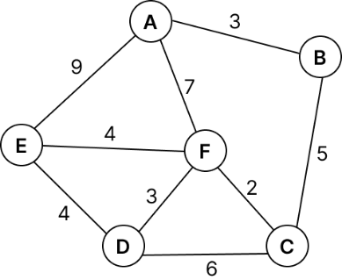
- A) Convert the following expression from infix to postfix showing the content of the stack at each step.
A*(B*C+D*E)+F
B) Explain strictly, complete, and extended binary trees. Write an application of tree in DSA.
- Explain the priority queue in data structure. Write a program to implement enqueue and dequeue in a circular queue.
- A) Explain Divide and conquer with an example (quick sort).
B) Explain the various asymptotic notations.
Group C
Attempt any two questions. [2*15=30]
- Define singly linked list. Write full/complete code used to perform the following operation in a single linked list:
  - To insert a new node at the end of the list
  - To remove a first node from the list.
  - To display the data from the linked list.
- What are the four rotations used in AVL trees? Elaborate with necessary examples. Construct a AVL tree for the following sequence of keys: 50, 20, 60, 10, 8, 15, 32, 46, 11, 48 and Perform the following:
- Show the AVL after all insertions.
- Delete the node with value 20 and show the updated BST.
- Write inorder, preorder, and postorder traversals of the final tree.
- Consider the arrival order of the data: 22, 45, 31, 17, 29, 56, 73, 12, 38, 49, 6. Also assume a hash function h(x)=x mod 11 Now answer the following:
- Insert the given data into the hash table. Use the chaining if a collision is occurred.
- Insert the given data into the hash table. Use the linear probing if a collision is occurred.
- Insert the given data into the hash table. Use the quadratic probing if a collision is occurred.

